**Assignment 2**

**Aim:** Data warehouse schema generation and OLAP operations using OLAPCube tool.

**Objectives:**

* To build cube and different reports in OLAP Cube Tool.
* To perform different OLAP operations.

**Problem Statement:**

**Case Study:**

A music company maintains following database.

* **Customers:** stores customer’s data.
* **Orders:** stores sales orders placed by customers.
* **OrderDetails:** stores sales order line items for each sales order.
* **Album:** stores album’s data.
* **Employees:** stores all employee information as well as the organization structure such as who reports to whom.

**Create different type of dimensions like simple, Hierarchical, relational and time.**

**Identify and create few measures.**

**Build cube.**

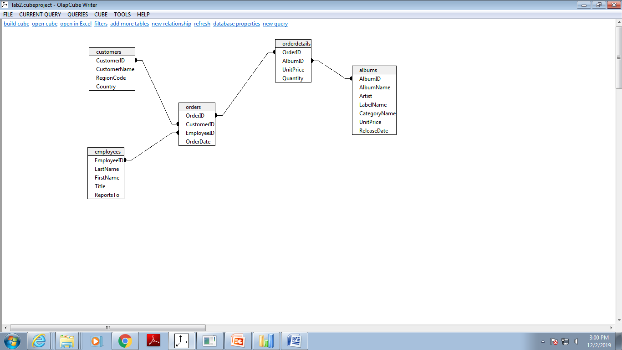

**Generate few reports based on different dimensions and measures.**

**1.Sales per category**

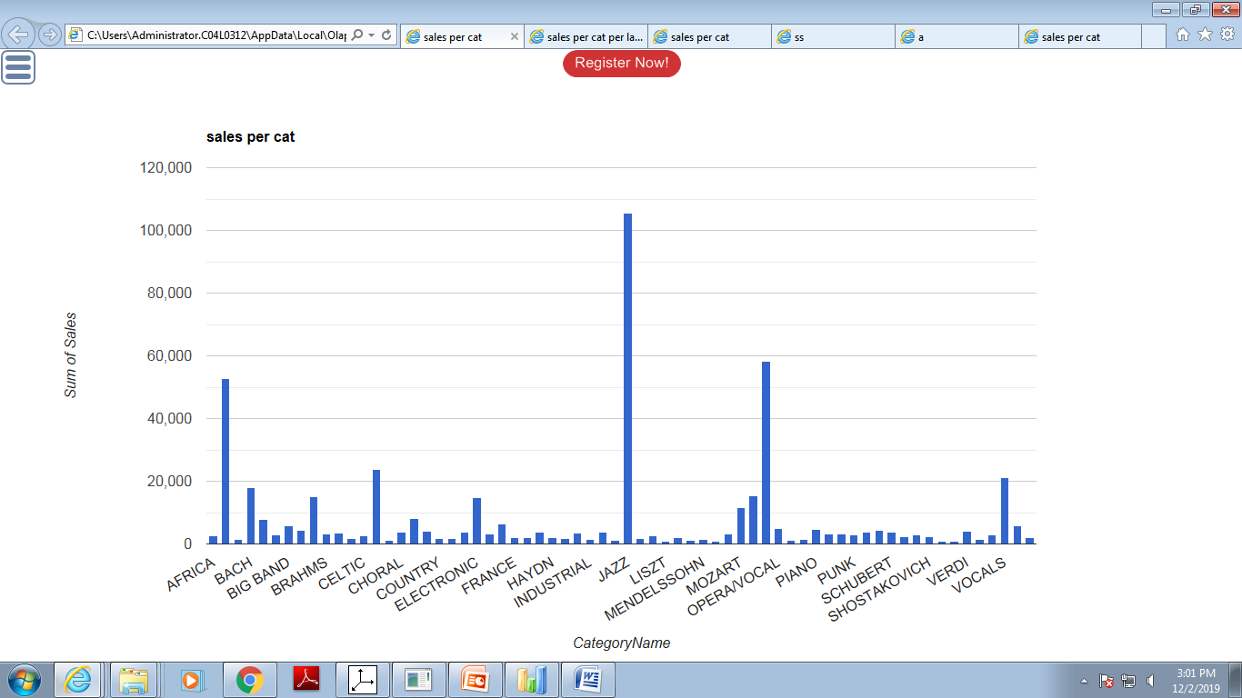

**2.Sales per category per label name**

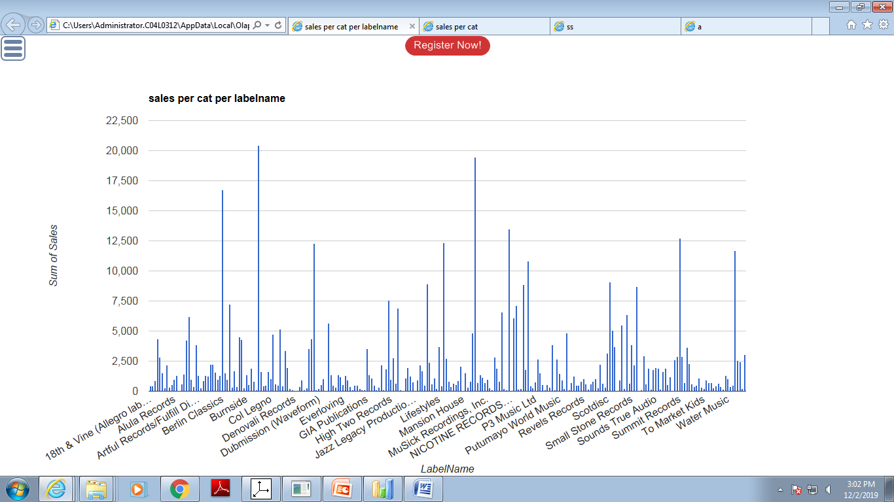

**3. Sales in Africa**

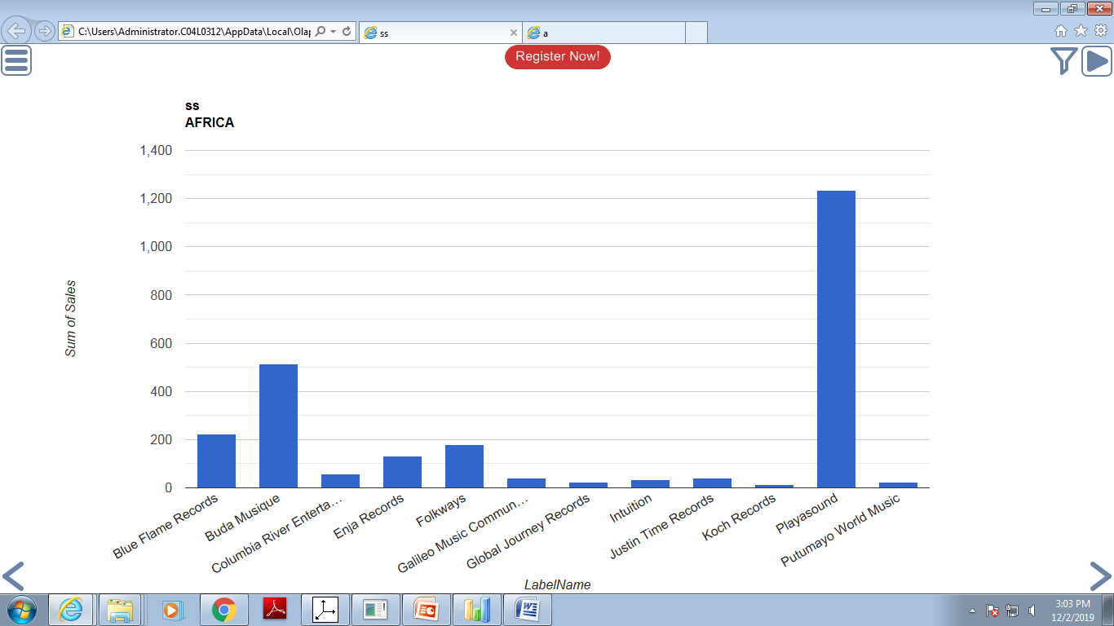

**Input:** Database

**Output:** Multidimensional cube and data analysis reports..

**Platform:** Windows

**Conclusion:** Thus, we have learned to build multidimensional cube and OLAP operations.